**FOOD FOR THOUGHT:**

**THE WORLD ON A PLATE**

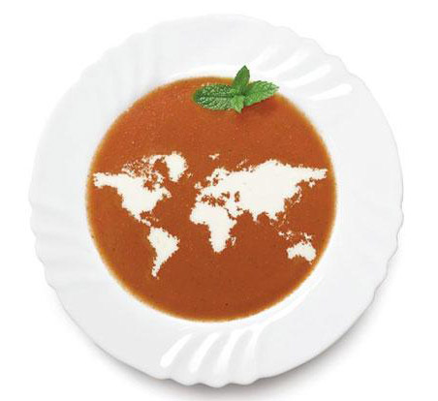

**Suman Bhagavathula** 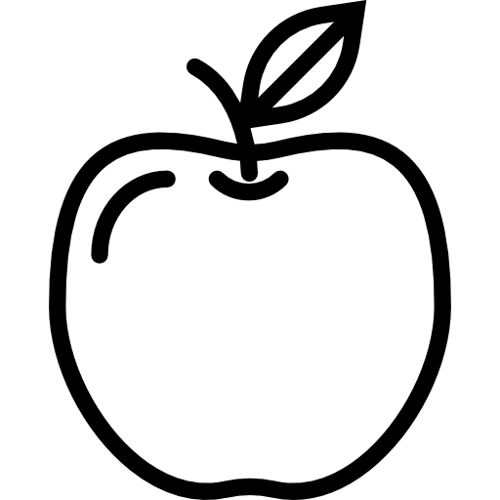

** Monique Bi**

**Ian Page-Echols **

** Ankit Tandon**

**Yeva Tynkova **

**University of Washington**

**HCDE 511 Information Visualization | Fall 2018**

**EXECUTIVE SUMMARY**

The goal of the *Food For Thought* project is to tell a story through a free-of-charge, publicly accessible interactive visual dashboard that allows users to explore meal choices around the world and learn more about the food components on a plate. Our team wants to take users on a tour of what representative cultural dinners (e.g. “signature dishes”) look like in different parts of the world, to the analysis of the ingredients comprising a particular meal, the production of those ingredients, as well as a cross-regional comparison.

*Visualization link*: <https://public.tableau.com/profile/ian.page.echols#!/vizhome/FoodForThoughtb/WorldonaPlatedash>

Challenges Overcome

**Technical challenges**: While some of our team had used Tableau before this project, our use of interactions between different dashboards was somewhat of a large task within the time available. Since our team were just meeting each other, an initial task was to figure out our collective capabilities and interests, and decide what was both reasonable to accomplish and interesting to us as a team. We also were using different types of representations than some of us were familiar with, which required learning more about the ways that Tableau works: how it can be used to represent data, the ways that representations, images, text fields, links, and more can be combined and interacted with, as well as how to create interactions between the dashboards. This required both design and prototyping, as well as technical and logistical tasks to accomplish our goals.

While Tableau is an amazing tool for data visualization, and has been used for this purpose since its inception, the design tools and the navigation aspects of Tableau are rudimentary compared to many graphical editing programs or “What You See Is What You Get” (WYSIWYG) website creation tools. The main dashboard creation process involves creating one or multiple worksheets, then creating a dashboard and dragging multiple worksheets and other elements into that dashboard. There are limitations to the way this process works. It is easiest to use the default snap-based method, but it is difficult to align elements precisely. Each element has its own formatting, sizing, centering, zooming, and more. There is currently no way to set the whole document or each dashboard to have standard Title, Heading, and Text sizes, and editing individual labels on a graph requires navigating to the worksheet holding that graph and editing from that sheet before finding your way back to the dashboard you were previously editing.

One can get granular movement of the placed worksheet elements by using “floating” elements, but there are currently no visible displays of location and size of these elements, no alignment tools, nor are there any nudge tools that would make aligning elements manually easier. Worse, when dragging elements, there often is no live redraw (using Mac OS X 10.14.1 using the current Tableau version 2018.3), so one has to drag, drop, then see if the last movement made one’s object placement better or worse than it was previously.

If one wants to rearrange a formatted and aligned Tableau dashboard that has already been created, it can be like a puzzle game figuring out which blank spaces to add before dragging out a new worksheet in order to get a centered or otherwise specifically placed sheet.

In short, Tableau might have saved us time in creating our visualizations. But it is possible that for a visualization that combines many elements and navigation between pages with the intent of creating a product that is uniform between the different pages, it might be advisable to use WYSIWYG or other CSS tools to create the navigation elements, and to place visualizations created with online tools like React within that overall structure.

**Design challenges**: From the get-go, our team envisioned two types of potential users to explore our visualization: a technically-savvy crowd interested in the data aspects of the design and cooking aficionados focusing on food-related storytelling. Since most of our usability testing was conducted on University of Washington college students, many of whom did not have technical backgrounds, the feedback received prompted us to expand the visual and verbal components of the design (e.g. popular recipes, featured dish photo, etc.) and slightly scale back on the more technical concept of “crop utilization” and more robust analysis of “production”. Potential future iteration of the design might see us focus exclusively on the technically advanced audience and feature economics and environment related visuals in greater detail.

Accomplishments

Our desire from the start of this project was to create an interactive visualization that included multiples types of representations, navigation elements, and the incorporation of graphic elements combined into an intuitive and easily usable whole that presented information about food. We largely were able to accomplish our goal.

**DESIGN CONCEPT**

Initial Research

Food visualization is a popular subject, with multiple artifacts published on various online platforms nationally and internationally. As a part of our initial research effort, we evaluated various approaches of presenting food-related content to audiences of different technical abilities and cultural backgrounds. Specifically, we looked at a plethora of sources (Appendix I), including popular publications (e.g. *National Geographic*), widely referenced online visualization blogs (e.g. *FlowingData*), international sustainability-focused agricultural research centers (e.g. *CIAT*), and interactive educational websites (e.g. *PaintMaps*). We assessed the sample visualizations from both Jock Mackinlay’s design criteria of expressiveness and effectiveness and Jacques Bertin’s visual encodings principles. Further, we cross-referenced the said visual references with Edward Tufte’s principles of graphical integrity.

Ideation

During the ideation sessions, our team brainstormed different visualization components and tasks to guide users on their culinary journey across the globe. In our process, we followed Ben Shneiderman’s user-centered visual format of the initial overview, zooming and filtering, and then providing details on-demand. In totality, the team envisioned 4 interconnected views that take users from a top-level regional cuisine introduction to several robust presentations of data filtered by nutritional values and production elements. The proposed functionality included, but was not limited to: panning, zooming, hovering, drop-down selections, and cuisine filtering by region. To contextualize the experience even further, we decided to include additional design components in the form of colorful “signature dish” photos of popular recipes, as well as flags from the regions.

**DATA**

Data Sources and Licensing

For our project, the team used 2 data sets, one detailing global food production and the other another highlighting recipes for global cuisines (Appendix II). The food production data are sourced from the Food and Agriculture Organization of The United Nations (FAO) and is licensed under the FAO’s open access policy, which allows for “immediate, irrevocable, and free access to information products subject to proper attribution.”

The global recipe dataset is sourced from Yummly, a digital food recipe provider with over 2 million recipes from cuisines around the world. The specific Yummly dataset we worked with was published as part of a Kaggle competition to predict the cuisine type of a given recipe based on its ingredients. As such, it is available in the public domain and is licensed as CC:BY allowing for full use with attribution. In addition, we obtained recipe data, nutritional value, and images from the Yummly website, which are all licensed as free to use with attribution. We took an extra step of reaching out to Sean McGlinchey, Chief Data Officer of Yummly, who confirmed full use of these data with attribution and has asked us to share the results with Yummly upon completion.

Data Acquisition

**Yummly dataset, recipes, and images**: The Yummly dataset we used was the training set for the Kaggle competition and was sourced as a .json file from the Kaggle competition page. In addition, we used the Yummly website to acquire a list of the most popular recipes and their nutritional breakdown for the different cuisines. We obtained these recipes by specifying cuisine choice, searching for, and ranking results by popularity. Images were sourced from these individual recipes.

**FAO dataset**: The FAO dataset was sourced as a .csv file via the FAO web data download tool, which allows users to specify the time period, data fields, food items, and countries for the desired dataset. Since we were interested in the differences between food imports and production across countries, we decided to look at 2 specific fields within the “Food Balance Sheets” category of the data: food import quantity and food production quantity. We decided to stay away from temporal data and specified the latest available year, 2013, as the time period for the production data. In specifying the desired countries, we created a mapping of the the cuisines’ regions in the Yummly dataset with countries in the FAO dataset. For the most part, we were able to identify the country associated with the cuisine fairly easily (e.g. Greek cuisine being associated with Greece). The 2 cases where the mapping was tricky was Cajun cuisine and Southern U.S. cuisine, both of which we decided to associate with The United States. Finally, in determining the food items from the FAO dataset, we had to create a mapping of Yummly ingredients based on the FAO standard for food classification. This mapping groups a number of ingredients such as cucumber, garlic, and scallions, among others, into a “vegetables, other” category as per the FAO’s standard.

**Wikimedia flag images**: The flags included as an additional graphical representation for each cuisine were sourced from Wikimedia as rights-free, public domain images.

Data Profile

The Yummly dataset was presented in a document-structured .json format and contained 39K recipes across 20 cuisines with 6,417 distinct ingredients. Each recipe contained an average of 11 ingredients per recipe. The schema of the data is outlined in the table below.

|  |  |  |
| --- | --- | --- |
| **ID (Numeric)** | **Cuisine (String)** | **Ingredients (List of Strings)** |
| 10259 | Greek | [lettuce, black olives, tomatoes, garlic, pepper, purple onion, garbanzo beans, feta cheese crumbles] |

The ingredients field consisted of a variable length list of ingredients stored in string format that could be iterated over. In addition, we accumulated a dataset of the most popular recipes and their nutritional values as broken down by calories, and the percentage of daily value of sodium, fat, protein, carbs, and fiber.

The FAO dataset was presented in tabular format and had the following schema (shown with the two examples included):

|  |  |  |  |  |  |
| --- | --- | --- | --- | --- | --- |
| **Country (String)** | **Item (string)** | **Element (string)** | **Year (Int)** | **Unit (String)** | **Value (Int)** |
| Brazil | Potatoes and Products | Production | 2013 | 1000 tonnes | 3570 |
| Brazil | Potatoes and Products | Import Quantity | 2013 | 1000 tonnes | 3570 |

The Year and Unit columns are the same for all rows in the dataset, 2013 and 1000 tonnes respectively. The Element column is a categorical data field that represents the type of data presented in the row and can be of 2 categories: “production” or “import quantity”. The value column represents the quantity of import or production of the item in the country. The Country column was used as a common key to join with the region of cuisine in the Yummly dataset. The Item column can be one of many food item categories associated with top ingredients across cuisines.

Data Cleaning and Processing

These data required considerable amount of processing and cleaning. Major steps are outlined below.

**Yummly ingredient data**: In order to surface the most popular ingredients across cuisines in the Yummly data, we created a python script that counted the occurrence of ingredients within recipes for each cuisine. As a result, we ended up with a list of the 85 most commonly occurring ingredient for all recipes. We noticed that the most common ingredients across cuisines were “water”, “salt”, “oil”, and other everyday ingredients that might not be considered unique to the cuisine and thus needed to be filtered out.

Once we removed the said “stop-ingredients”, we discovered that a lot of the most common ingredients were variations of one another. As such, we needed to perform a manual fuzzy combining technique to create our final list of top 10 most common ingredients for all cuisines. In this combination step, we grouped ingredients such as “purple onion”, “white onion”, “red onion”, “crushed onion”, etc. into a single ingredient “onion”. Similar groupings were performed on ingredients across all cuisines and helped surface the true usage of top 10 ingredients in each cuisine.

**FAO dataset**: Fortunately for us, the values in the FAO dataset all had a unit of 1000 tonnes, so the team did not have to perform any data manipulation prior to making comparisons between Production and Import Quantity across Countries and Items. The FAO dataset was joined with the Yummly dataset on region/country and ingredient/food group.

**Yummly recipe, nutrition, and image data**: To obtain the most popular recipes and their nutritional value and images, we crowdsourced a manual lookup amongst our team members. Each member was assigned a cuisine and tasked with identification and download of the most popular recipe, its nutritional value, and the corresponding image. Since the nutritional value of the recipes was all in % of DV, no cleaning was required in order to make comparisons between various nutrition categories.

The images were used directly for the Recipe & Nutrition worksheet, and were manually incorporated into text graphics using Photoshop for use as the Region buttons.

**Wikimedia flag images**: The flag images were of somewhat random dimensions and sizes, and were all manipulated in Photoshop to arrive at standardized sizes that would not cause interface delays and would be easily usable.

Data’s Strengths and Limitations

The multivariate 2D data served as a high quality source to compare various aspects of global cuisines and food production and consumption. The individual ingredients, the cuisine they occur in, and the country associated with that cuisine are all data of nominal type. We were able to generate counts of the ingredients as well, which was a ratio data type. The locations associated with cuisines have a geographic representation in the form of a country and are thus an interval data type. As such, we have a healthy mix of data types that can be used in conjunction with one another to tell a story about how cuisines differ across the world and show production and food imports for each cuisine.

Data limitations related to having to perform a series of joins, requiring the team to make assumptions in a number of places. This included, but was not limited to, deciding on a specific country to associate with a cuisine, grouping specific ingredients into food types, and selecting a most popular recipe associated with a cuisine. The latter was determined with the help of the Yummly site-wide search engine.

As we were not performing data analysis on the coordinates of the cuisine images on our map dashboard, the coordinates for the regions were adjusted slightly to gain higher readability for regions that were close enough to cause our images to overlap.

**USER EVALUATIONS**

Initial Prototype

The initial paper version of the prototype (Appendix III) featured 4 interrelated page views:

1. An introduction depicting a “world on a plate”.
2. A map showing regional distribution of the most popular cuisines across the globe.
3. A page showcasing each cuisine’s top ingredients.
4. An ingredient-level nutrition and production breakdown presented on a spider chart, a map and a line graph.

The navigation was envisioned through mouse clicking and hovering on an object of interest. “Go back” functionality was incorporated through a mini-map located at the top left corner.

Evaluation Methods

The *Food For Thought* team has tested its design on 6 users who represented a fairly diverse educational spectrum. Specifically, the participants were comprised of 1 PhD, 2 masters, and 3 undergraduate students of male and female genders. The participants’ technical expertise and domain knowledge ranged from advanced to very basic. The first 3 tests were conducted in a classroom setting using paper prototypes, while the subsequent 3 tests took place on the University of Washington campus using an interactive Adobe XD digital prototype presented on a Mac laptop. The prototypes were black and white in both cases, but featured select color elements to simulate object selections. The usability testing team consisted of a moderator interacting with the participants and an observer responsible for note taking. All tests were conducted in-person.

We received additional usability testing information and feedback during the HCDE 511 Visualization Showcase from others in UW Masters and Certificate programs. The participants interacted with a near complete version of our visualization. One team member asked questions, while another took notes of participant reactions and comments. We also received reviews of our visualization from these same participants through the Peer Feedback class deliverable.

Insights – First Round

User feedback, while generally positive, pointed to several areas needing attention and potential reevaluation.

|  |  |  |
| --- | --- | --- |
|  | Go-back page navigation | * Slightly confusing due to the presence of multiple maps, occasionally on the same page |
|  | Geographic breadth of data | * Lack of clarity whether the information was the country- or region-level |
|  | Spider graph | * Considered overly complex and was advised to be replaced with a radar chart |
|  | Top ingredient information depicted as a circle | * Considered “hard to read” due to text curvature and suggested to be arranged lineally |
|  | Production information | * Confusion over multiple categories visualized on a dual axis over time * Connection to the design’s themes of food and health * White space interpretation on the map: whether it signified low production areas, a lack of production altogether, or just a lack of information for that area * Production location did not necessarily convey any information about the popularity of an ingredient around the globe |
|  | Cross-regional comparisons | * Requests for more interactivity and insight |

The strength of the design related to its clever use of food themes, metaphorically leaving the participants hungry for more information. Everyone loved the “world on a plate” interface, with the comments ranging from “it is really cute” to “you have done a nice job here”. The navigation, aside from the go-back functionality, was also considered a success with not a single participant struggling to find their way around. Similarly, the concept to concept flow of the visualizations generated a lot of positive feedback, with one participant in particular raving about its “very intuitive” nature. A map depicting the top regional cuisines was considered “a good way to start reflecting on the world’s food habits” by taking users on a literal and metaphorical journey across the globe.

Iterations – First Round

After aggregating and discussing the feedback, the team incorporated multiple suggestions into the iterated design (Appendix IV).

|  |  |  |
| --- | --- | --- |
|  | Go-back page navigation | * Added a “Back to Map” title to the mini-map at the top left corner |
|  | Spider graph | * Replaced with a radar chart containing a color-coded legend to differentiate between the top ingredients |
|  | Top ingredient information depicted as a circle | * Converted to a list instead of a pie chart |
|  | Production information | * Converted into a bar chart for greater clarity * Removed the second map to eliminate navigational confusion * Broken down into 2 separate components, production and utilization * Focused on presenting the latest information on a single axis |
|  | Cross-regional comparisons | * Separate visualization for all 3 statistics: ingredients, production, and nutrition * Added a drop-down list functionality to allow users to change a region on the fly * Incorporated a “Back to [Region A] Statistics” label to make the go-back to the statistics screen navigation more seamless * Included a “Click to Compare” label to alert users that comparison was possible in the first place |

Insights – Second Round

The second series of usability studies had the participants play with a digital prototype themselves following the *Think Aloud* protocol.

Overall, everyone loved the “cool concept” and felt that the flow was “great”; however, there were some technical and thematic suggestions to make the experience more engaging and intuitive.

|  |  |  |
| --- | --- | --- |
|  | Most popular ingredient list | * Ranking aspect was not clear enough; suggested numbering * Included more line items than the corresponding production and nutrition charts |
|  | Radar chart | * Less technical participants suggested replacing a radar chart with a pie chart for greater clarity * More technical user proposed keeping the radar chart but showing nutrition for only 1 ingredient at a time and switching ingredients by clicking on the side legend |
|  | Production and utilization | * Lack of clarity about the definitions of “production” and “utilization” |
|  | Health theme | * Could be conveyed more clearly * Requests to introduce healthiness comparison across regions |
|  | Overall experience | * Requests for addition of popular recipes and storytelling elements to create a richer experience |

On the plus side, both the concept and the visuals were considered engaging and user friendly. The expectation of clicking on a region, learning about a popular meal, and then evaluating its components was fully met. The interactivity of the design (e.g. drop-down menus, clicking on hot-spots to switch to a different page, etc.) were universally praised. A desire to test a more advanced color version was voiced. The process sparked the participants’ curiosity and inspired them to learn more.

**FINAL VISUALIZATION**

Design Walk-Through

The final visualization incorporated most of the feedback from the second round of usability testing and significantly expanded its overall interactivity and visual appeal (Appendix V).

The entry screen features a “world on a plate” interactive graphic, with the accompanying legend on the right briefly summarizing the core aspects of the design and inviting users to begin exploration. The following screen highlights the top 20 regional cuisines spread out on a world map per their respective geographies, each in a form of a verbally notated circular button featuring an image of this region’s “signature dish”. This is one of the main interactive filtering mechanisms of the design, determining subsequent visual content shown to a user. Also included on this screen is a “Credits” icon that shows a tooltip when the cursor hovers over it. The tooltip lists the team members names, as well as the sources of our datasets and images.

Upon selecting a regional cuisine by clicking on one of the circular buttons, users are taken to the Ingredients & Production screen. The regional selection title (e.g. Mexico) and the country flag appear on the top of the page. Towards the left, the ranked 10 most popular ingredients are arranged as a vertical list, with the ingredient names and the corresponding “usage” percentages shown side-by-side. The accompanying note in the middle provides additional context to the rankings and directs users’ attention to the production and import segment of the page. The Production portion evaluates the same top 10 ingredients from the “locally grown versus imported” standpoint and allows for interactive sorting. Finally, the right side of the page invites users to explore the region’s “signature dish” by clicking on either the dish name itself or a circular button located right under it.

The Recipe & Nutrition screen features a photo of the “signature dish”, its nutritional breakdown by elements and total calorie count, the ingredients for the recipe and an interactive link that takes users to the recipe-specific Yummly webpage for additional information. A short note in the middle of the screen further contextualizes the experience. The comparison options at the bottom right corner of the screen invite users to make cross-regional, cross-category evaluations.

The Comparison screens feature an interactive drop-down list of regional cuisines to assess against the originally selected cuisine. Comparisons are enabled for ingredient production metrics, “signature dish”’ nutritional breakdown and calorie count. To return to the previous screen, users are advised to click on Back to Ingredients & Production icon at the top left corner. To explore a different regional cuisine altogether, users are to click on the Back to Map icon at the top left corner.

Critical Evaluation

Our design sought to explore and incorporate a variety of the best visualization practices and core concepts covered during the course. Specifically, we aimed to make the product as user-friendly and engaging as possible by carefully balancing graphical and verbal elements and the use of interactive content. The data-ink ratio is intentionally kept low with succinct, straight-to-the-point charts thoughtfully arranged around verbal and pictorial layouts. Interactive exploration is driven by filtering, sorting, hovering, drop-down menus, clickable links, page view transitions, and multiscreen linking functionality. Multivariate 2D relational data is encoded using the length, color, shape, and position visual attributes. The consistency of visual encodings is preserved on all page views. The principle of Importance Ordering is featured in the depiction of the top 10 most popular ingredients. Visual expressiveness and effectiveness are achieved by presenting carefully selected content pieces and formats validated through multiple rounds of user feedback. Graphical integrity is ensured by presenting data in thematic and visual context and careful labeling of axes and units. Finally, the design aims to engage a wide audience of food lovers and therefore is intentionally kept at a technical level accessible to an average user.

Future Work

The topic of *Food for Thought* is open-ended. The sky’s the limit as far as the amount and sources of information available, as well as the different types of representations it would be possible to design. Below is a short list of changes and additional features we would like to implement and test in the future.

We only included one recipe per cuisine in our visualization due to our need to manually clean and format the Yummly data that we used. In the future, we would design a scheme that would allow us to automatically bring over a larger dataset. This would require the design of additional interface elements to navigate between recipes. We would also design search tools and other more analytical visualizations that would be enabled by a larger dataset. Because the Yummly database was mostly created by users in the United States, it would be ideal to find additional data sources that include more foods and recipes from internationally-sourced datasets.

A specific element of our design that we would like to address in future versions is the size of the circle for representing Calories in the Recipe & Nutrition and the corresponding Comparison pages:

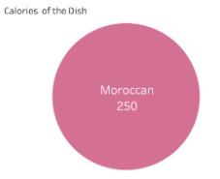

Calories compare section from the Compare Recipe & Nutrition page (taking the Moroccan versus the Jamaican cuisines example):

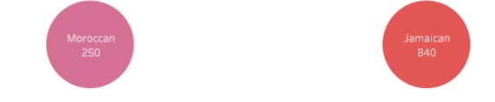

While it is not readily obvious in the first screenshot where we have only one number and nothing to compare against, the point is made in the latter screenshot where we note that the size of the circle in both cases is the same and has no bearing to the fact that the Calorie count is different between the two visuals. While we know from the theory of Visual Perception that human mind has a relatively weaker ability to compare two areas, that particular factor does not favor us in this case since it is apparent that the two circles are the same size even when the labeled number of calories is significantly different. In future work, we would like to fix this discrepancy while keeping a visual method of comparing calories. We left this representation as-is because it added visual interest as compared to a plain text label, or an additional single line bar chart, which also had the downside of being confusing sitting next to the other bar chart already on this screen.

We would also like to add an action to clear the filtered cuisine when returning to the map screen. As it is, when the “Back to Map” text and region choice button is selected at the top left of the Recipe & Nutrition dashboard, the currently selected cuisine has to be deselected by clicking anywhere in the interactive space and then again on the cuisine of choice. Only the previously selected region icon will be easily visible as well, as the others are “deselected”, making them light grey and possibly unclear that they are interactive. This is also currently inconsistent, as a new user to the visualization won’t see this the first time on that page. A fresh load or deselected map page only needs a single click on the cuisine of choice to proceed. It is only on return to the Choose a Region dashboard that this double clicking action is needed.

An additional piece of visualization that we would love to include in the future is a pop up in the Choose a Region map page that would show an initial summary of each cuisine. For example, moving the cursor over “Cajun” could pop up a short descriptive sentence, possibly from Wikipedia or another descriptive source to give a general idea of trends in tastes, ingredients, or spices. One possible example below from Wikipedia:



One suggestion along similar lines was a section that lists a “fun fact” for that cuisine, either as a pop up on the map / Choose Region dashboard, or possibly in the text field on the Recipe & Ingredients page. This could be in regards to some unique spice, information about the country or region that the cuisine is generally from, or even a quote from a celebrity about a particular recipe.

A related addition would be a visualization of cuisines with correlating ingredients or other dimensions. For example, when you move the cursor over Spain on the Choose a Region dashboard, you would see lines connecting highly related cuisines with one color, and less related cuisines with another color, and no lines connecting dissimilar cuisines. If you were familiar with Spanish food and liked it, you could use this to find other foods that you might find tasty.

On our Recipe & Ingredients page, we are showing the popular ingredients of the current cuisine to the left of a popular recipe. It would be interesting to highlight the popular ingredients of that region in the currently viewed recipe. For example, in a crepe recipe you might see wheat and milk highlighted and a line or other indication pointing towards that ingredient in the Top 10 Ingredients section to make clear why they are highlighted.

There are other ways we could add interactions between the already represented information that could add some insight. One might be a link from the individual ingredients in either the Top 10 Ingredients section, or the recipe listing section that could show a menu of other recipes that use that ingredient.

Our current calorie and “% of daily value” nutrition visualizations are based on a 2,000 calorie diet. This is a very common practice, and this is generally what is used on packaged food in the United States. However, because we’re working in an interactive medium this could be changed to be more directly relevant to each person using the visualization. We could add fields to enter one’s current and desired weights to then show whether this dish might help or hinder users in their eating and health goals.

In a future visualization that includes a greater amount of data, it might be necessary to create a routine to convert and incorporate images from the data sources for use in the visualization. As it was, there was a fair amount of manual effort needed to create the graphics we used.

An interesting addition would be to include a search result for Youtube videos of the preparation of the recipe. This could allow users to decide if a dish is too complicated to make, or to find new cooking videos to watch.

**Appendix I: Initial Research**

*National Geographic*, “What the World Eats”: <https://www.nationalgeographic.com/what-the-world-eats/>

*FlowingData*, “Cuisine Ingredients”: <https://flowingdata.com/2018/09/18/cuisine-ingredients/>

*FlowingData*, “Backbone of the Flavor Network”: <https://flowingdata.com/2011/12/27/backbone-of-the-flavor-network/>

*CIAT*, “The Changing Global Diet”: <https://ciat.cgiar.org/the-changing-global-diet/>

*PaintMaps*, “Agricultural Land (% of Land Area)”: <https://paintmaps.com/statistics/5/Agricultural-land-percentage-of-land-area-on-world-map>

**Appendix II: Data Sources**

FAO dataset obtained from the official website:

<http://www.fao.org/faostat/en/?#data/QV>

Yummly ingredients dataset obtained from a Kaggle competition:

<https://www.kaggle.com/c/whats-cooking/data>

Yummly recipe and nutrition data, and recipe and region representation images obtained from the Yummly website:

<https://www.yummly.com/>

Region Flag images obtained from Wikimedia. One example link to the flag for Greece:

<https://commons.m.wikimedia.org/wiki/File:Flag_of_Greece.svg>

**Appendix III: Paper Prototype**

|  |
| --- |
| **Entry Page** |
|  |
| https://lh6.googleusercontent.com/OFk9jERPRF41OyXBrWlS4PcoFKTWPf5WHy5sYHwrPZIRNK9xifdShqkl4DUvCWJYDYUVPT6KaKe5926HvyzL-10CVmmAeQFH5fcQv9m23CHlse-wEC_LHZoDRFilNONOhSb9sQsr |

|  |
| --- |
| **Choosing Region** |
|  |
| https://lh3.googleusercontent.com/NWS-BQftx_Y--_eKhAgXRT2lWdt_k-UF52jXFS63jLXZzz3g0rnI-EYCNlGsoPYzeckn766laQS7_hRPanynRcdmeMb8CIplPPS0E84SlGEjvFRXR2YH_3aQnBsPY0EM4l0UOBGJ |

|  |
| --- |
| **Ingredients, Nutrition, and Graph View** |
|  |
| https://lh5.googleusercontent.com/itT2FwWtkNZwJunJFcn2eg7gN-VnU8Vkczmd1gxXdN3VOTHsZnJI2EnAQ3Ng-PStYJBltrBeio1k18IIAy1rcbMnsc4JtdlQVfMrA5iJYiBMdK9sEbxgHYuS1X0_muDtglJqmtwW |

|  |
| --- |
| **Ingredients, Nutrition, and Map View** |
|  |
| https://lh6.googleusercontent.com/2KrRjtqkGONJ9-87AwL0otMkKJlgXJvTR93IGFMlfXf_mSHdPvlnefkygnGqC5YLJqLkuPiTzu69EiHXA1jB9xEtWsWPKq6H-eK59_azZyg0p2FwCnMbIj7QE9oT2HJcj07X-Ick |

**Appendix IV: Digital Prototype**

|  |
| --- |
| **Home Page** |
|  |
| https://lh4.googleusercontent.com/1qb8di8C7CHG0qOp-LDZ41e7MMRKRB8jYH1AUCAeMQIIRA2k3lgYm3pzn7bBfEjBVjmCkJW3DD4Uhp3H56DvjOOPexxJzDmkYvdVpcrFjgM_r4PCB1q7-Tq_V9VDCXMH-wmSn93f |

|  |
| --- |
| **World Map for Different Cuisines** |
|  |
| https://lh4.googleusercontent.com/FFvG34uQ1K9iflFgHugy2rET4JeoihE8xRonbtZTVh2jgODXqS2hKUV8hWtavuWI8aMNcWFO6aYxn0_ijNtAhzs7sTwVSfbe3IoYut1QcGQkkVPQozYtT2vYjcb4gtFscjy1CyIb |

|  |
| --- |
| **Cuisine Information Breakdown** |
|  |
| https://lh4.googleusercontent.com/j7BoeYsWPRSITQuh7m1tRkjoFxQOOFtenTb_czVwDON8WBFTwNkkEBLyKEYBzq04SSOj_HEuTij95K4Blq4PIwxVUFz9_MgZNX8WTjgWbpAcGHJG6mua0HoTRo_Y2EHPWwOzyWCf  **Ingredient Nutrition Comparison**  https://lh3.googleusercontent.com/NNmD-vPTO_vWIT-CMH1ON_tnuFsvvhubjuSS4ijS7XMZARKwTE11hiDRz_q0Edf4DgPS8STwzNQOPhg3zq7tNSqdA_vqGs754Vg1tduWKAW5SLEO24d4fNIBGt1JQIYniy00EvXb |

|  |
| --- |
| **Production and Utilization Comparison** |
|  |
| https://lh4.googleusercontent.com/hFZbSPw-WthU9wqLEFPdVtMm-w_EZO2J_TzAO4iM2h5g9WKQy5gzHcWNC4fvhrX4zVhyhGvUjtGKr_lIgbdzEEh52KVSvBN8YTBOoceSB4deaZjt0CYi0qKZcIwlIhmbm4TuGGoC |

|  |
| --- |
| **Region B Drop-Down Selection** |
|  |
| https://lh6.googleusercontent.com/L_8TNf-HLz8vk5qFaUgfB-q_WAa8yNWjyiAu71uCFg1-N32GLHOMK9h9WcVwcR4FpE66FNItVMM5QZS5QjN_uJ42LDaY8Ld5NnYO9_N_gRPPBTIuuZIm7w2DT_ISrR-gQH8s4T7R |

**Appendix V: Final Visualization**

**Introduction:**

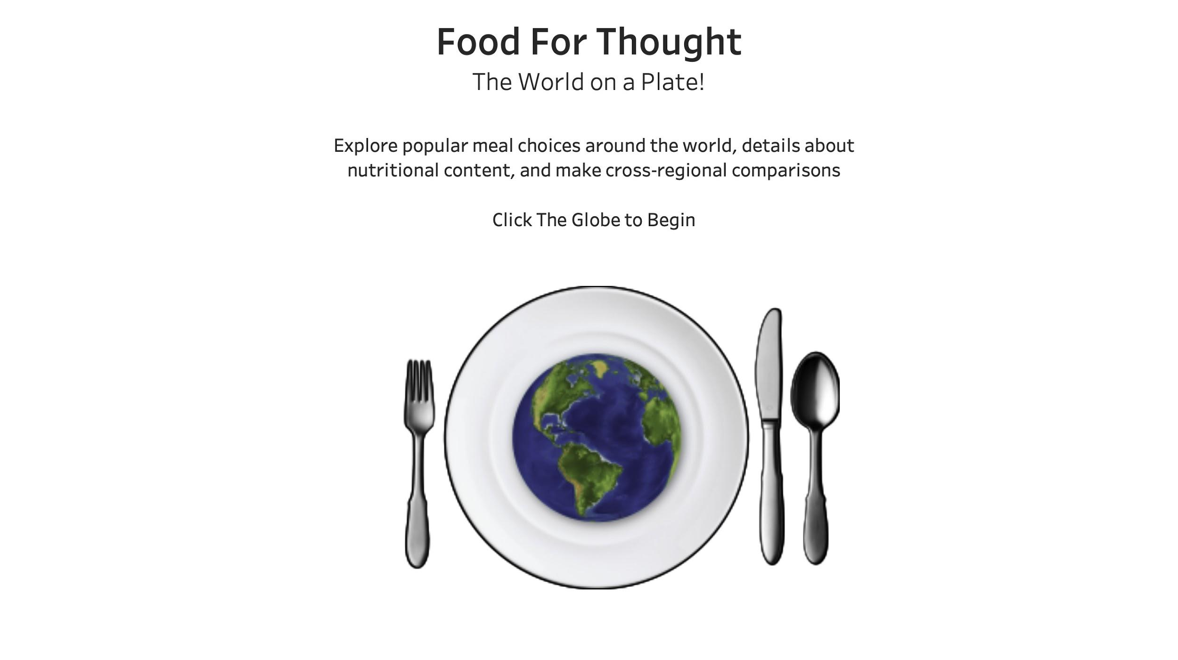

**Choosing a Region:**

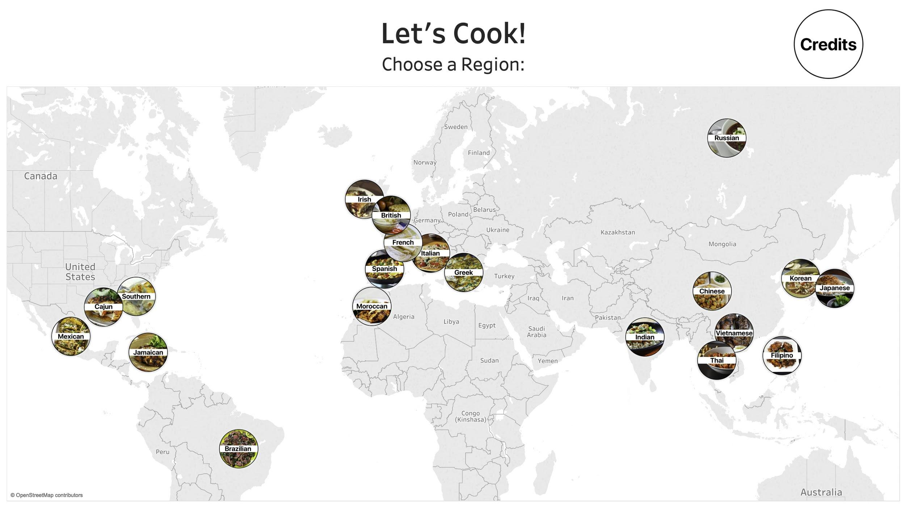

**Ingredients & Production:**

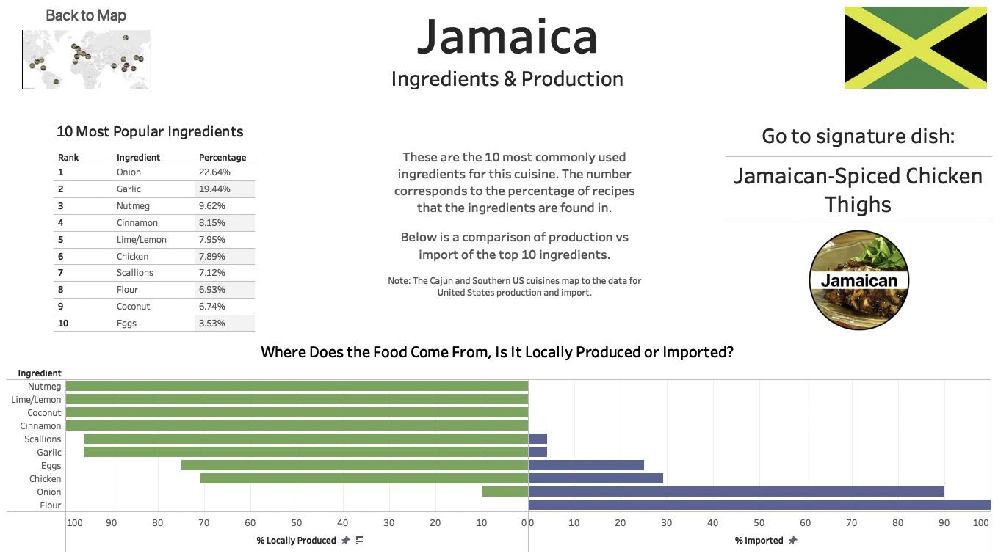

**Recipe & Nutrition:**

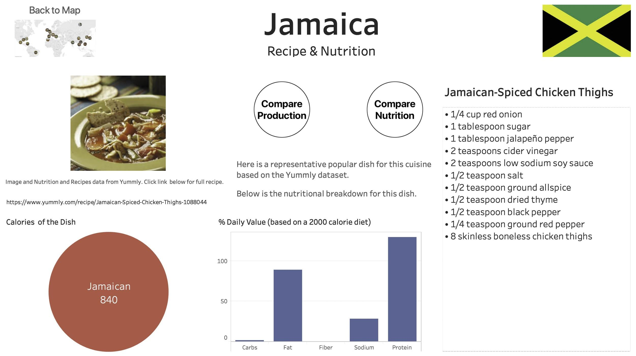

**Compare Ingredients & Production:**

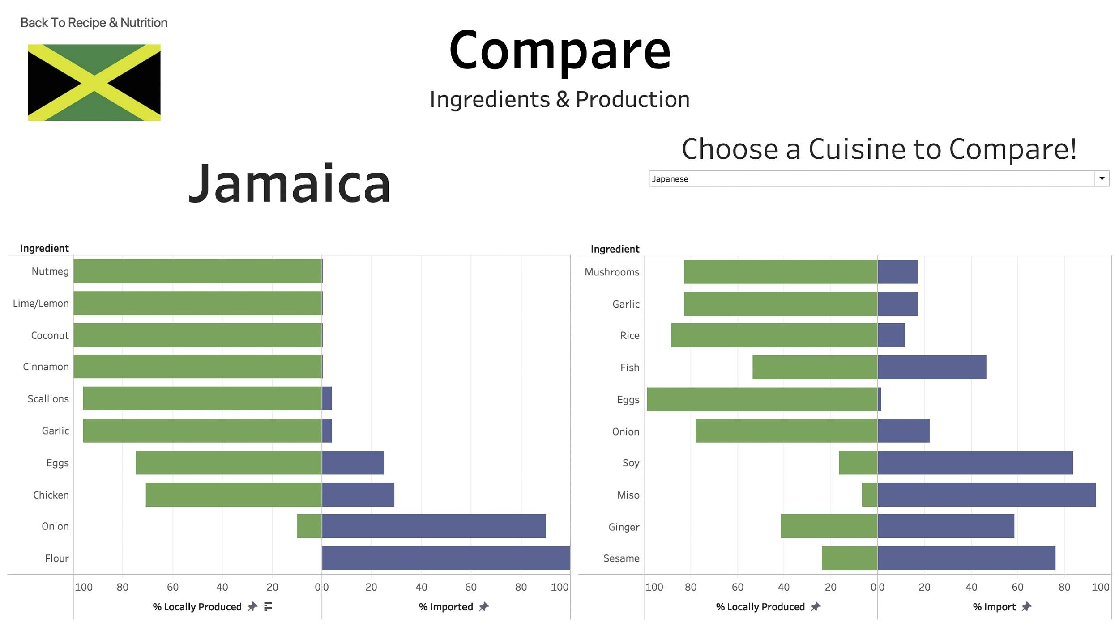

**Compare Nutrition & Calories:**

